Spicy Thai Basil Chicken (Pad Krapow Gai)

Ingredients
1/2x
1x
2x
Original recipe (1X) yields 2 servings
- ⅓ cup chicken broth
- 1 tablespoon oyster sauce
- 1 tablespoon soy sauce, or as needed
- 2 teaspoons fish sauce
- 1 teaspoon white sugar
- 1 teaspoon brown sugar
- 2 tablespoons vegetable oil
- 1 pound minced chicken breast
- ¼ cup sliced shallots
- 4 cloves garlic, minced
- 2 tablespoons minced Thai chilies, Serrano, or other hot pepper
- 1 cup very thinly sliced fresh basil leaves
- 2 cups hot cooked rice

Directions
- Gather ingredients.
- Whisk chicken broth, oyster sauce, soy sauce, fish sauce, white sugar, and brown sugar together in a bowl until well blended.
- Heat large skillet over high heat. Drizzle in oil. Add chopped chicken and stir fry until it loses its raw color, 2 to 3 minutes.
- Stir in shallots, garlic, and sliced chilies. Continue cooking on high heat until some of the juices start to caramelize in the bottom of the pan, about 2 or 3 more minutes.
- Add about a tablespoon of the sauce mixture to the skillet; cook and stir until sauce begins to caramelize, about 1 minute.
- Pour in the rest of the sauce. Cook and stir until sauce has deglazed the bottom of the pan. Continue to cook until sauce glazes onto the meat, 1 or 2 more minutes. Remove from heat.
- Stir in basil. Cook and stir until basil is wilted, about 20 seconds. Serve with rice.
- Serve hot and enjoy!
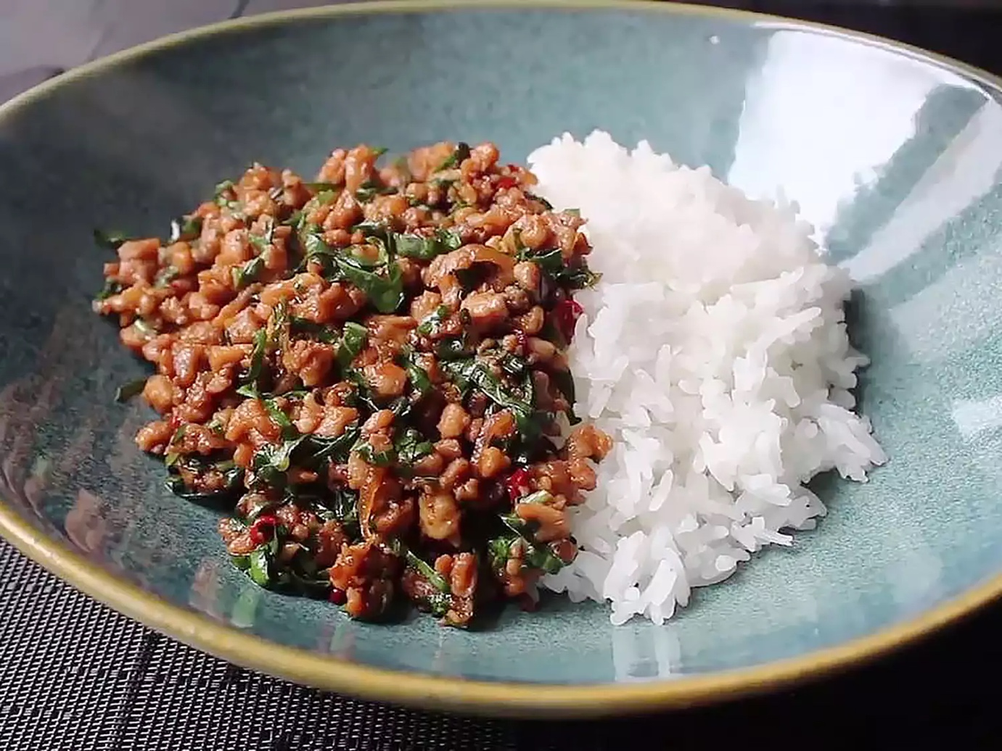
https://www.allrecipes.com/recipe/257938/spicy-thai-basil-chicken-pad-krapow-gai/

Classic Chili Con Carne
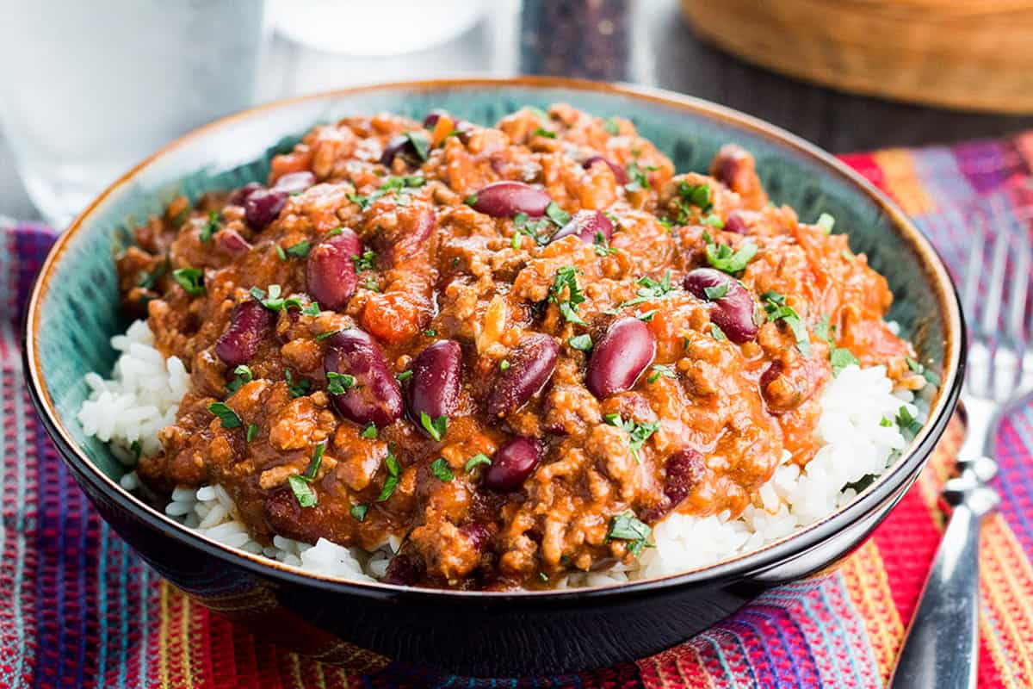
Serves 5 people

Ingredients
- ▢ 2 tablespoons olive oil
- ▢ 2 pounds ground beef
- ▢ 1 onion (large) (chopped)
- ▢ 4 cloves garlic (chopped)
- ▢ 2 tablespoons ground cumin*
- ▢ 2 tablespoon dried oregano
- ▢ 2 teaspoons smoked paprika
- ▢ ½ teaspoon cayenne pepper (plus more if you like it spicy)
- ▢ 2 tablespoons tomato paste
- ▢ 28 oz can crushed tomatoes
- ▢ ½ cup beef stock
- ▢ 14.5 oz can kidney beans (drained)
- ▢ salt and pepper (to taste)
- ▢ good handful fresh parsley (chopped)
US CustomaryMetric

Instructions
- Heat the olive oil in a large pan over medium heat. Add the onions and sauté until lightly golden, 2 to 3 minutes. Add the garlic and fry another minute.
- Add the ground beef; fry until fully cooked and no pink shows at all in the meat (about 8 minutes).
- Add the cumin, oregano, paprika, cayenne pepper, and tomato paste and cook, stirring about 2 minutes.
- Add the tomatoes, beef stock, and beans. Season to taste with salt and pepper, stir in the parsley, and bring to a simmer over low heat.
- Cook, stirring occasionally, until the chili thickens slightly, about 1-1⁄2 hours.
https://www.errenskitchen.com/classic-chili-con-carne/

